BUSINESS INTELLIGENCE LAB – UNIT 2
EXPERIMENT 6
DASHBOARD AND SCORECARD DEVELOPMENT USING MICROSOFT POWER BI
1. AIM
To design and develop an interactive Executive Dashboard and Business Scorecard using Microsoft Power BI for monitoring organizational performance and supporting business decision-making.
2. SOFTWARE REQUIREMENTS
- Microsoft Power BI Desktop
- Global Superstore Dataset
- Power Query Editor
- DAX (Data Analysis Expressions)
3. THEORY
A Dashboard is a visual interface that presents important business metrics, trends, and performance indicators in a consolidated view.
A Scorecard is a management tool used to compare actual performance against predefined targets using Key Performance Indicators (KPIs).
Power BI provides cards, charts, slicers, filters, and interactive features to create dashboards and scorecards.
4. IMPLEMENTATION / PROCEDURE
4.1 Dashboard Planning
- Opened the existing Power BI project.
- Identified the key business metrics required by management.
- Selected suitable visualizations for presenting performance indicators.
- Planned the dashboard layout.
4.2 KPI Dashboard Development
- Created an Executive Dashboard page.
- Added KPI cards for Total Sales, Total Profit, Total Orders, and Profit Margin (%).
- Created visualizations for Sales by Region, Sales by Category, Monthly Sales Trend, Top 10 Customers by Sales, and Profit by Segment.
- Formatted the visuals for readability and consistency.
4.3 Interactive Features
- Added slicers for Region, Category, and Year.
- Tested the slicers using different selections.
- Verified the dynamic response of the dashboard visuals.
4.4 Business Scorecard Development
- Created a Business Scorecard page.
- Inserted one Table visual containing:
  - Total Sales and Sales Target
  - Sales Achievement (%) and Sales Status
  - Total Profit and Profit Target
  - Profit Achievement (%) and Profit Status
  - Total Orders and Order Target
  - Orders Achievement (%) and Orders Status
- Compared actual performance against the targets.
- Applied performance indicators: Achieved, Partially Achieved, and Not Achieved.
- Used conditional formatting to represent performance status.
4.5 Business Analysis
- Compared sales across regions to identify the best and worst performing regions.
- Compared profit across categories to identify the most and least profitable categories.
- Examined the dashboard findings.
- Prepared a business recommendation based on the analysis.
5. OBSERVATIONS
- KPI cards provided a summary of important business metrics.
- Charts presented sales and profit performance across different business dimensions.
- Slicers allowed interactive filtering by Region, Category, and Year.
- The Business Scorecard displayed actual values, targets, achievement percentages, and performance statuses.
- Dashboard analysis supported the identification of business performance trends.
6. BUSINESS RECOMMENDATION
Management should regularly monitor sales, profit, and order performance using the dashboard and scorecard. The company should strengthen activities in high-performing regions and review the factors affecting lower-performing regions and less profitable product categories.
7. RESULT
An interactive Executive Dashboard and Business Scorecard were successfully developed using Microsoft Power BI. Key business metrics were visualized through KPI cards, charts, and slicers to support performance monitoring and business analysis.
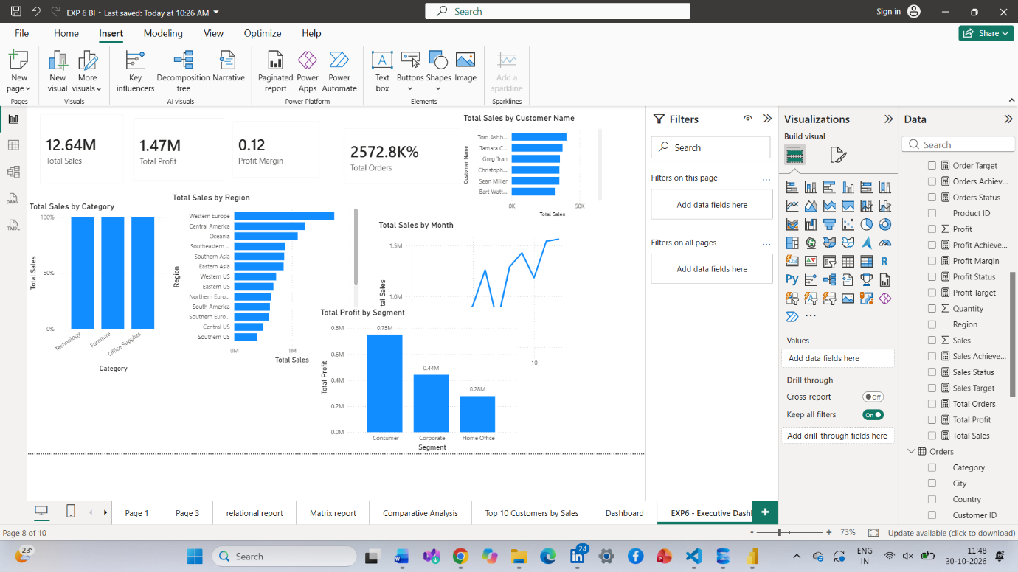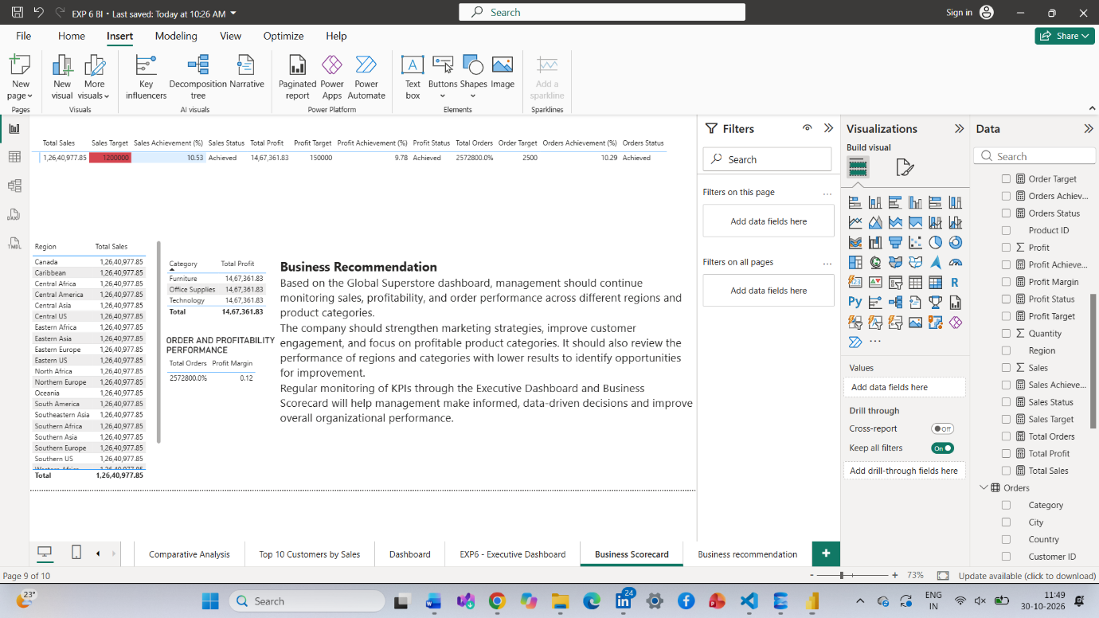
8. LEARNING OUTCOMES
- Designed interactive dashboards using Power BI visualizations. (CO5-BT6)
- Created KPI-based scorecards for performance monitoring. (CO5-BT6)
- Applied visualization best practices in dashboard design. (CO3-BT3)
- Analyzed business performance using dashboard insights. (CO3-BT4)
- Developed recommendations based on data-driven findings. (CO5-BT6)
9. REFERENCES
- Sharda, Delen & Turban, Business Intelligence and Analytics.
- Cindi Howson, Successful Business Intelligence.
- Microsoft Power BI Official Documentation.
- Global Superstore Dataset – Kaggle.

